COMP90024 Cluster and Cloud Computing
Project1: HPC Twitter Geoprocessing

Author: Zhengyu Chen() & Fei Zhou (972547)

- Introduction
In this assignment, a parallelized application has been implemented to process the geocoded Twitter dataset, discover the Twitter usage and the most frequently used hashtags within each area of Melbourne. In this report, the multiprocessing approach will be introduced. The performances of the application with different computation resource will be analyzed and discussed against the Gustafson-Barsis's law and the possible approaches for improvement will be introduced as well.

- Parallelized Processing

In this project, the master-slave mode is used to parallelize the processing. Multithreading is used in one core version. The main thread takes the responsibility of reading in and preprocessing the data. Since the size of the BigTwitter.json is very large, the file is read in line by line as a data stream. Every read-in line will be appended to the list and after reading 100 lines data each time, the main thread will put this list into the queue for the worker thread to use. Then the list will be emptied and this procedure will be repeated until all data from the file have been read in. After the worker thread finished processing all the bundles from the queue, the counting result will be returned to the main thread and the final statistics will be generated. The UML sequence diagram of multithreading version is as follow: 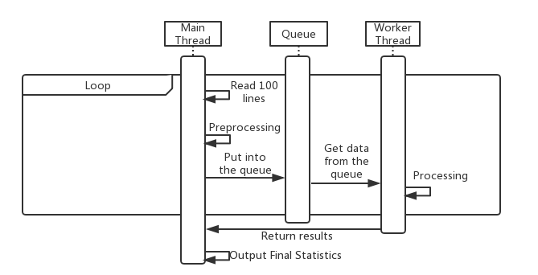

In the multi-process version, the message passing interface is used for cross-process communication. The process with rank 0 takes the responsibility of reading in and preprocessing the data while the other 7 processes are used for parallelizing the analyzing part. After reading 100 lines each time, the rank 0 process will send the data to one of the processes for processing. After processes finished all processing task, the results will be sent back to rank 0 and the final statistics will be generated. The UML sequence diagram is as follow:

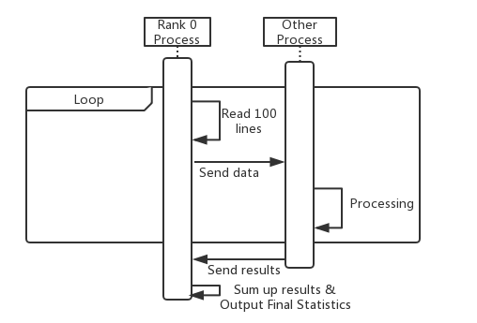

- Performance Analysis
The running time and relative speed of processing the BigTwitter.json with different resources is as follow:

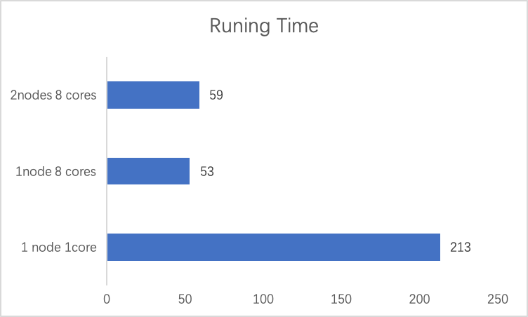

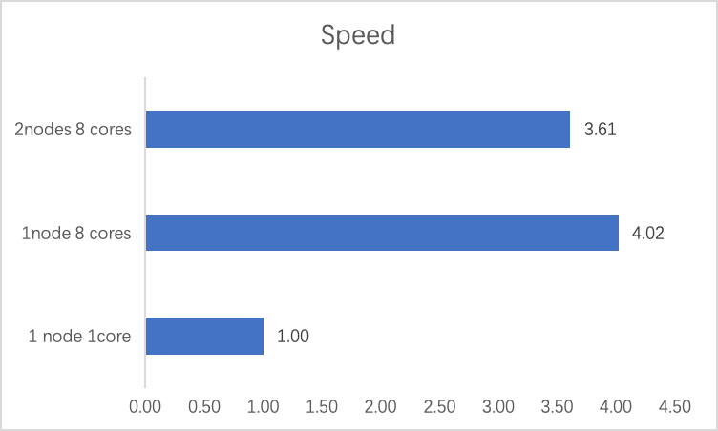

As to the result above, processing the same file with 8 cores within 1 node can speed up to around 4 times compared to the 1 core version. Within the multi-process program, 1 core is used to read in the data and sum up the final results while the remaining 7 processes are used to parallelize the processing task.

According to the Gustafson-Barsis's law, since we have N equals 7 and S is approximately 4, we can calculate that the a, which is the fraction of running time sequential program depends on parallel parts, is 1/2. So the fixed parallel time is approximately equal to the non-parallelable part. In our application, the file read-in and the sum up of the statistics are non-parallelable.

The cost of inter-process communication with the MPI is also a fraction for the performance. The cost becomes more significant when dealing with 2 nodes environment which affected the running time by 6 seconds. For the 2 nodes version, the parallelized program can only speed up to 3.6 times compared with the 1 core version. And this performance dropping is due to the increase in communication cost between 2 nodes.

- Conculsion and Possible Future Improvement

In this project, the application for processing the twitter geodata has been developed in both 1 core and multi-core version. The speed of the multi-core version has increased the speed of processing by 4 times when running in a 1 node 8 cores environment compared to the one core version. The bottleneck for this application is that the file reading part is not parallelable and the communication cost between different nodes is significant. For future development, the file reading part can be parallelized to make the application become SPMD to reduce the cross-node communication cost and speed up the file read-in part.

- Appendix

Script for 1 node and 1 core
#!/bin/bash
#SBATCH --partition=cloud
#SBATCH --nodes=1
#SBATCH --ntasks=1
#SBATCH --ntasks-per-node=1
module load Python/3.6.1-intel-2017.u2
python3 MultiThread.py

Script for 1 node and 8 cores

#!/bin/bash
#SBATCH --partition=physical
#SBATCH --nodes=1
#SBATCH --ntasks=8
#SBATCH --ntasks-per-node=8
#SBATCH --cpus-per-task=1
module load Python/3.6.1-intel-2017.u2
mpirun python3 MultiNode.py

Script for 2 node and 8 cores

#!/bin/bash
#SBATCH --partition=physical
#SBATCH --nodes=2
#SBATCH --ntasks=8
#SBATCH --ntasks-per-node=4
#SBATCH --cpus-per-task=1
module load Python/3.6.1-intel-2017.u2
mpirun python3 MultiNode.py

